**Proposed Dashboards for United Airlines Staff**

Mark Kuether

University of Wisconsin

Data Science 780 – Data Science and Strategic Decision Making

Professor Dr. Thomas Buck

August 8th, 2021

**Best Practices**

When creating visual displays to convey ideas or data, it is important to understand your audience. In the case of business users, the audience is focused on tasks to further the success of their business. However, even with this unified goal, the needs of different business users will vary based on their role in the organization. Data and charts used in displays and presentation need to reflect both the purpose and the roles the audience may play within the organization. Data presented to line workers or customer facing individuals would likely have a tight focus on the day to day or even hour to hour data that is very specific to their jobs. Data presented to upper management would likely contain data on broad performance measures for the entire company or department (Galention & Schuermann, 2014 p. 86).

In order for data to be meaningful for this audience, it should be based on key performance indicators and measures of success commonly used in the organization (Schmarzo, 2013, p. 201). While some of these are generic, other measures will be specific to the industry itself.

Overall, all charts or displays need to have some common properties. First, they should be relatively simple and only display the one or two measures specific to the purpose of the graph or chart. Charts should have a minimum of markings (i.e. labels) that distract from the message being presented in the chart. It is important for users to see and understand the data and charts without requiring much effort to study the charts. If a concept cannot be displayed in a single chart without producing a cluttered or complex display, it is best to break it into multiple data displays (Galention & Schuermann, 2014, p. 115-124).

Dashboards provide an ideal medium for displaying multiple types of data. It allows the viewer to easily compare different charts or data displays to better understand their cumulative message. Dashboards also tend to be used to monitor dynamic data, so measures that do not fluctuate, such as fixed costs, are not beneficial for dashboards. Overall, dashboard data needs to be laid out in a logical and meaningful way for the viewer (Galention & Schuermann, 2014, p. 97). If the dashboard has a single page, only data on the key indicators and processes would be displayed. Multipage dashboards can present a way of organizing multiple types of data or allowing the user to drill down. Regardless of whether a single or multi-page dashboard is used, all users should have some mechanism for reviewing the lower level details behind the charts and displays. This could range from either an interactive display to a url link that redirects a web browser to those details.

**Company Overview: United Airlines**

United Airlines is an international airline which flies over 4,900 flights a day to over 350 different airports using a fleet of about 777 aircraft. To accommodate this traffic, they employ a hub and spoke model to transport passengers and cargo around the world as efficiently as possible. Accomplishing this mission also requires partnerships with 8 different regional airlines as well 27 international partners as part of the Star Alliance of air carriers. United Airlines currently employs about 96,000 people filling various roles such as pilots, flight attendants, technicians, dispatchers, load planners, security officers, instructors, caterers, and passenger service people. About 85% of United employees belong to one of about 6 different unions which require annual or multi-year contract negotiations. In the realm of customer service, United has a loyalty program “MileagePlus” which awarded approximately 6.1M miles plus rewards in 2019 (United Airlines Inc.).

In its operations, United Airlines uses big data to improve their customer experience, improve their employee experience, increase revenue generation, and improve operational reliability. An improved customer experience includes easy and straight forward flight bookings, easier airport operations such as check ins or navigating to a connecting gate, and seeing a consistent corporate message when interacting via mobile, web, or other social media outlets.

Improved employee experience includes having meaningful, accurate, and current information to relay to customers, as well as having an employer who listens to its employees. Areas for revenue generation includes providing new offers to customers, as well as ensuring current fees and pricing schedules are competitive and sustainable. Operational improvements may involve improved weather preparation, maintenance planning, as well as having airplane and engine parts where they are needed when they are needed.

United accomplishes these goals with integrations between Teradata resources, Hortonworks products such as Hive and Hadoop, and Apache products such as Nifi (Olson, J). (Olson, J).

**Examples of Data Usage by Job Position**

The first data user would be the CEO of United Airlines, Scott Kirby. The role of a CEO is described well on Indeed’s site as:

“The CEO oversees the overall direction of an organization. They are responsible for developing and implementing strategies and policies to ensure that the organization will meet the goals determined by the board of directors. They monitor the organization’s performance indicators and any budgetary and financial activities. They appoint the Managers and department heads. They identify cost-cutting measures to improve the operations and performance to meet the organization’s goals” (Indeed).

Some of the big picture areas the CEO needs to keep an eye on are operating costs, income, and profitability or the airline as a whole. With the large fuel consumption by jet aircraft, fuel usage, costs, and availability are a key component of tracking operating costs. Fleet reliability and logistic efficiency is also key to minimizing operational costs. One measure to provide clarity on income would be the success of customer loyalty programs. Finally, specific to 2020 and 2021, the state of the Covid-19 pandemic in the markets served by the airline would be important to monitor. However, this likely would require deeper analysis than a dashboard.

Someone with Scott Kirby’s experience and position is likely to be an optimist (United Investors Resources; Kirby, S.) seeing opportunities and benefits above detractors. With this in mind, I would recommend creating a dashboard split left and right between elements with revenue bearing data on the left, and elements with operational cost data on the right. This allows a quick comparison between the two elements, but emphasizes the revenue aspect. The revenue measures I would include on the left would be:

* Revenue Passenger Miles
* Load Ratio (Revenue Passanger Miles / Available Seat Miles)
* Total Revenue per Available Seat Mile
* Total Miles Awarded (frequent flyer miles.)

(United Annual Report)

The costs side would include

* Cost per available seat miles
* Cumulative Fuel Consumption
* Cumulative Fuel Costs
* Maintenance hour / Revenue Flight hour
* Revenue Flight hour / Total hour
* Total Miles Redeemed (frequent flyer miles)

(United Annual Report)

The second data user would be the customer service manager of airport operations at Chicago O’Hare International airport. The job description of this position would be similar to this one found on the LinkedIn site.

“The Manager of Customer Service is responsible for overseeing all aspects of strategic and operational initiatives within the Customer Service Department at Hub locations. The manager is responsible to lead, align and develop Assistant Managers, front line supervisors and front-line employees. Responsible to execute station financial and operational plans and adjust as needed throughout the year to achieve corporate and local station goals. They must possess operational expertise and decision-making capability, financial, technology, logistics and management disciplines to support and create strategic objectives and direction. The manager must possess experience in goal directed leadership, analytical thinking, financial controls, budgeting, customer service and policy/procedures. Must have in depth knowledge of department work rules and strong relationship with the unions. They will interface with other departments including: Operations Control Center, Flight Ops, Inflight, Maintenance, in addition to government agencies, business partners and vendors and must be able to team for station success” (LinkedIn).

To build financial plans, this person would need airport labor cost and airline income attributed to airport traffic. Building forecasts based on staff and passenger levels could help determine optimal staffing and reduce customer wait times. Since customer satisfaction is directly affected by flight delays and cancelations, this person would also want a summary and forecasts of those for the specific airport or region. While external factors cannot be controlled, preparing for these events, and managing customer expectations appropriately relies on accurate and timely data of these factors. This dashboard would contain:

* Average check in processing time
* Average check in per hour
* Weather delays / Total Flights (out of airport)
* Operations cost / Passenger revenue.

The third data user would be a gate agent working at Chicago International airport. This is a customer facing position responsible for various duties including booking reservations, printing boarding passes, determining alternative flight options, helping people check in and board, and assisting with travel issues as they arise. This position requires focus, patience, empathy, and a positive attitude (United).

To help passengers with questions or problems, agents need to have information on flight status, weather status, delays, passenger lists, seat assignments and flight capacity. This dashboard would include:

* Hourly Ontime percentage for all hubs and major airports.
* Airports affected by weather.
* Passenger check ins for specific flight
* Specific flight schedule deviation.
* Specific flight boarding time.

**Dashboards**

For all dashboards, the first page uses low latent data to provide a daily operations guide. The viewer uses this to see any rapid changes, or new trends emerging. Higher level managers need not chase each trend, but should be aware of them to guide employees as well as employ the changes into future planning.

The daily charts in these dashboards are for illustration only and do not contain actual data from United Airlines. All data in these dashboards are based on data from values in the United Annual Report (United Annual Report) or data found on third party sources (Wikipedia; Airport-Ohare.com; worldpopulationreview.com; United). Daily averages were estimated from annual figures, while data points were generated from random normal distributions around the average. Other data is estimated from third party sources, or invented for illustration. The quarterly charts are based on actual quarterly data from the United quarterly reports. (United First-Quarter; United Second-Quarter; United Third-Quarter; United Fourth-Quarter)

**CEO Dashboard**

The first page of the CEO dashboard contains all daily trends with a 14 day history. This allows the CEO to see daily changes and easily spot new trends as they emerge.

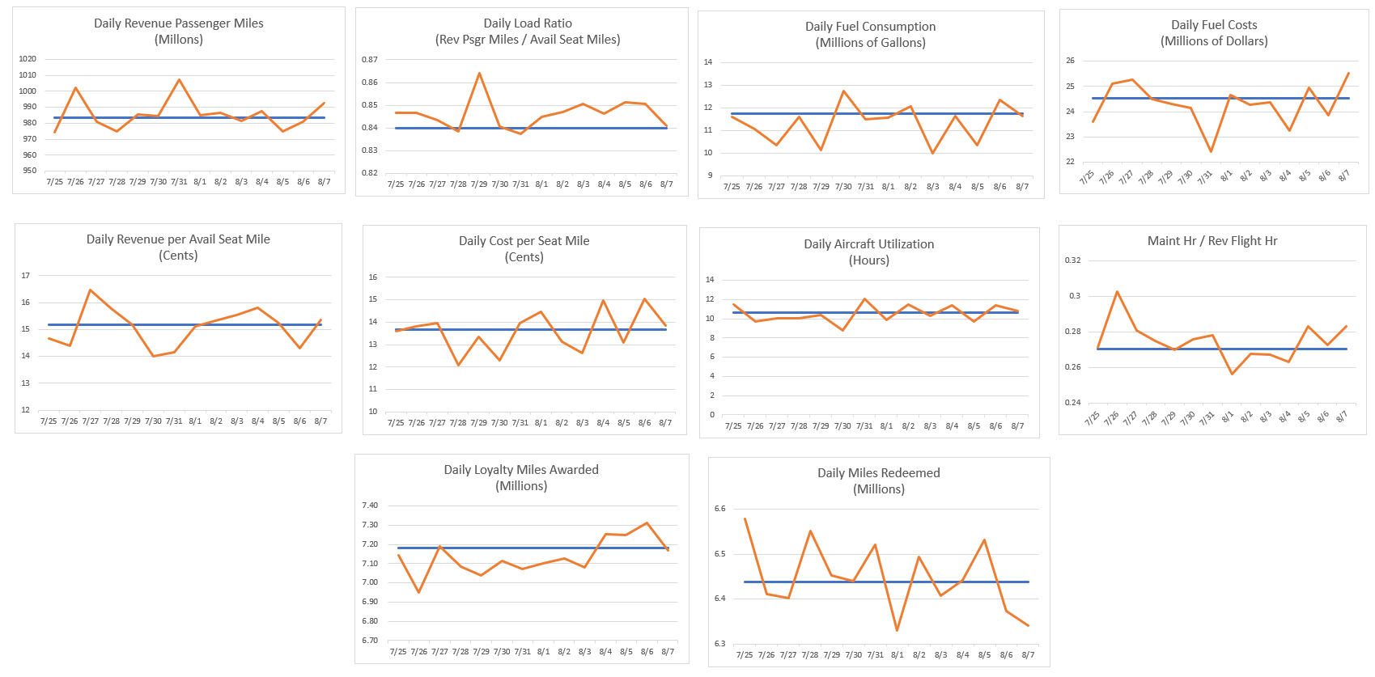

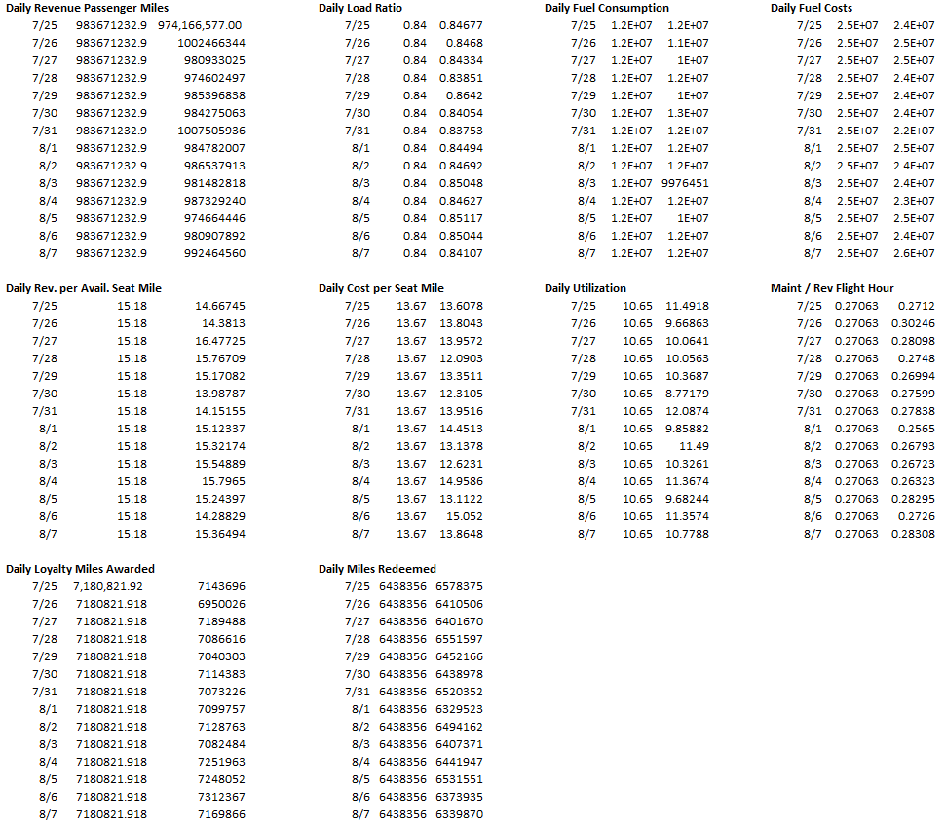

The second page of the CEO dashboard contains quarterly data used for analysis. This is on the second page as it does not require prompt attention by the viewer.

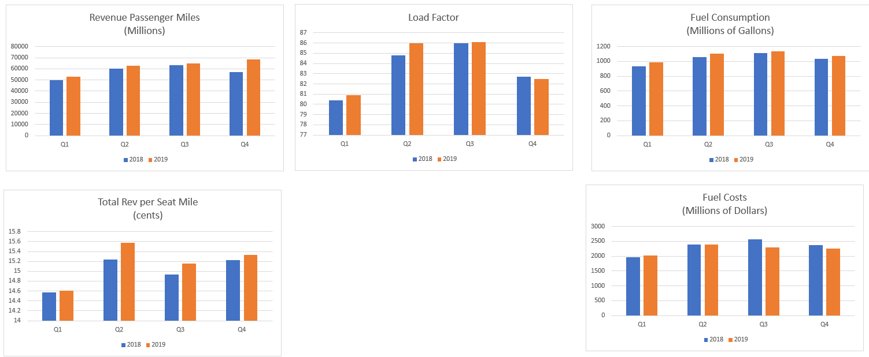

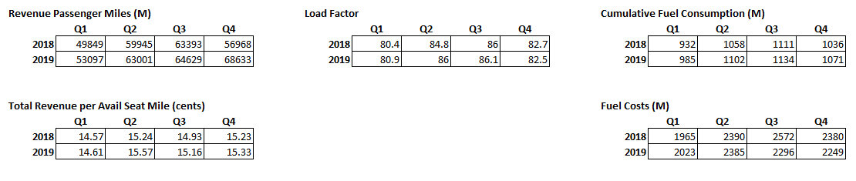

**Airport Manager Dashboard**

Like the CEO, the Airport manager uses a line tend to track emerging tendencies. Some measures, such as the number of passengers checking in per hour, or the On Time ratio have upper or lower guidelines to indicate when a proactive action needs to occur to help reduce customer stress.

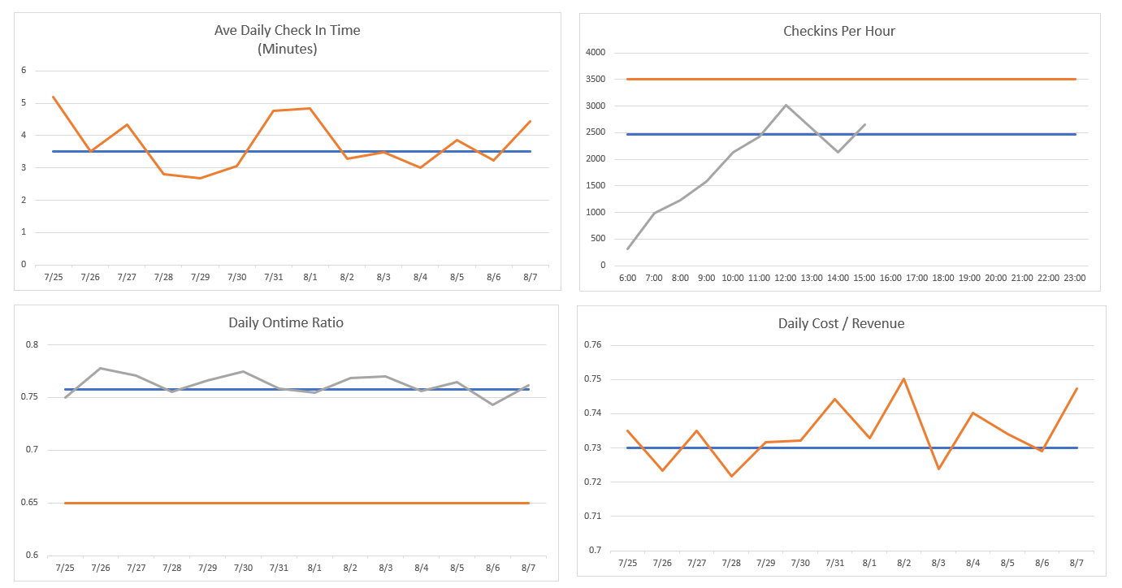

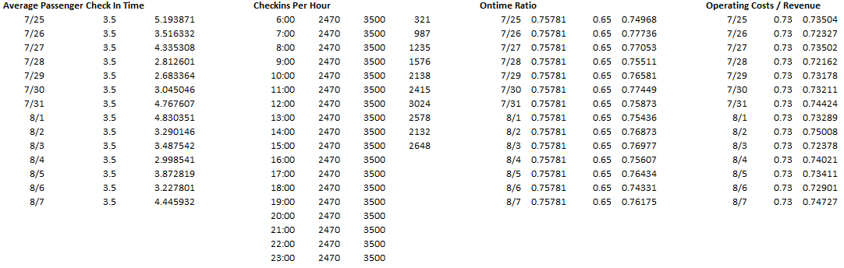

**Gate Agent Dashboard**

Unlike the managers, the gate agents need to focus on their current status in order to maintain aircraft schedules. Since gate agents are dealing with travelers who may be heading to almost any domestic destination (United), they need a comprehensive list of conditions at different airports. This allows them to set customer expectations, and know when more work may be needed to find a solution for the customer.

In addition to these measures, gate agents would need the ability to do custom searches. That functionality is not included in this dashboard.

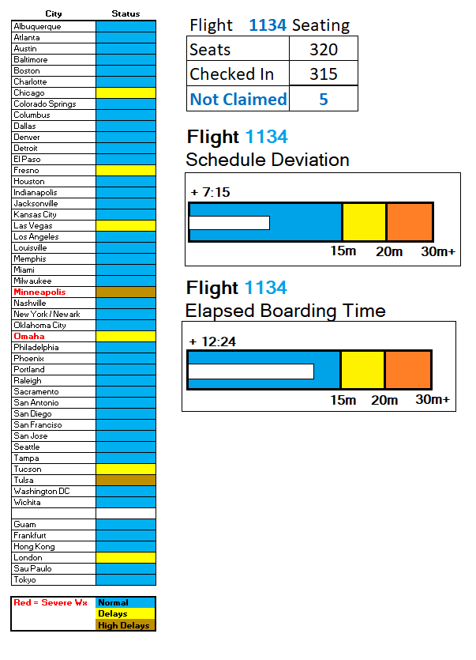

**Summary and Conclusions**

The dashboards used by each employee depends on their responsibilities. The CEO needs to see the broad relationships between internal and external factors in order to make decisions to guide the company to future success. Meanwhile, the gate agent is focused on the immediate task of checking passengers in, helping them with travel issues, as well as boarding and deplaning aircraft as efficiently as possible. While the gate agent’s single performance will not have a great effect on the company, the collective performance of all gate agents will certainly matter. It is because of that that they need to be provided tools and feedback so they are able to maximize their individual performances.

While different employees may use the same type of data, presenting it for different roles requires very granular data as well as a large amount of processing. Both the CEO and the airport manager use revenue in some form. However, the airport manager needs to have revenue specific to their airport and their operations. For low latent data, this information needs to be processed quickly to separate out the revenue and costs from that specific airport against all revenue and costs for the airline. Further, if changes are made to flights or aircraft due to weather or downtime, this will affect measures such as available seat miles. With almost 5000 flights occurring every day, big data tools, such as Hadoop, become a key to ensuring the data can be presented in a timely and meaningful way. This is critical to help business leaders make intelligent choices in the ever changing business landscape of modern aviation.

**References**

Aircraft Maintenance Checks (n.d.). Retrieved August 8, 2021, from Wikipedia page, <https://en.wikipedia.org/wiki/Aircraft_maintenance_checks>

Chief Executive Officer Job Description: Top Duties and Qualifications. (n.d.) Retrieved August 8, 2021, from Indeed page, <https://www.indeed.com/hire/job-description/ceo-chief-executive-officer?gclid=EAIaIQobChMI0OD2tPGa8gIVMQV9Ch1d7QzYEAAYASAAEgLKd_D_BwE&aceid=>

Company Leadership, (n.d.) Retrieved August 8, 2021, from United Investors Resources page, <https://ir.united.com/index.php/corporate-governance/company-leadership/#scott-kirby>

Customer Service Representative – Full Time. (n.d.) Retrieved August 8, 2021, from United Careers site, <https://careers.united.com/job/13333258/customer-service-representative-full-time-lihue-hi/>

Galentino, R., & Schuermann, P., (2014). *Data Fluency – Empowering Your Organization With Effective Data Communication.* Indianapolis, IN: John Wiley & Sons.

Kirby, S. (2020, May 2). A message from Scott Kirby, United’s new CEO, Retrieved from United site, <https://hub.united.com/united-message-new-ceo-scott-kirby-2646034128.html>

Manager – Airport Operations Customer Service. (n.d.) Retrieved August 8, 2021, from LinkedIn page, <https://www.linkedin.com/jobs/search/?currentJobId=2674963212&keywords=united%20airlines%20operations%20manager>

Nonstop Destinations from Chicago, IL, (n.d.) Retrieved August 8, 2021 from United.com page, <https://www.united.com/web/en-us/content/travel/route-maps.aspx?POS=US>

Olson, J. (2018, June 21). Big Data at United Airlines. Retrieved from Slideshare site, <https://www.slideshare.net/Hadoop_Summit/big-data-at-united-airlines>

Schmarzo, B., (2013). *Big Data – Understanding How Data Powers Big Business*. Indianapolis, IN: John Wiley & Sons.

The 200 Largest Cities in the United States by Population 2021, (n.d.) Retrieved August 8, 2021 from worldpopulationreview.com site, <https://worldpopulationreview.com/us-cities>

United Airlines, Inc. (2020, February, 25). Annual Report on Form 10-K For the Year Ended December 31, 2019. Retrieved from United Investors Relations site, <https://ir.united.com/>

United Airlines, Inc. (2019, April, 16). United Airlines Reports First-Quarter 2019 Performance. Retrieved from United Investors Relations site, <https://ir.united.com/financial-performance/earnings-releases>

United Airlines, Inc. (2019, July, 16). United Airlines Reports Second-Quarter 2019 Performance. Retrieved from United Investors Relations site, <https://ir.united.com/financial-performance/earnings-releases>

United Airlines, Inc. (2019, October, 15). United Airlines Reports Third-Quarter 2019 Performance. Retrieved from United Investors Relations site, <https://ir.united.com/financial-performance/earnings-releases>

United Airlines, Inc. (2020, January, 21). United Airlines Reports Fourth-Quarter 2019 Performance. Retrieved from United Investors Relations site, <https://ir.united.com/financial-performance/earnings-releases>

United Airlines Departures From Chicago O'Hare Airport (ORD), (n.d.) Retrieved August 7, 2021 from Airport-Ohare.com site, <https://www.airport-ohare.com/departures-airline-united-airlines>